**Advent Devotional**

**Kid’s Corner Ideas**

**Share the Light of Jesus**

<http://www.redtedart.com/gifts-kids-can-make-decorated-candles/>

[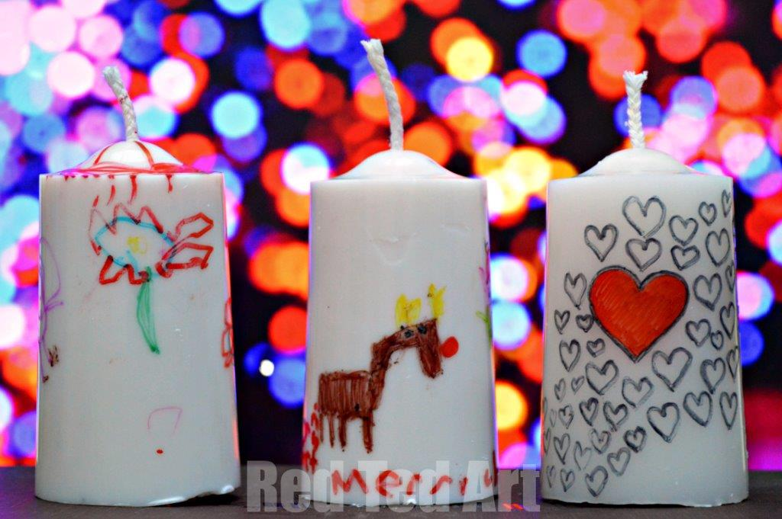](http://www.redtedart.com/2013/11/27/gifts-kids-can-make-decorated-candles/gift-ideas-for-kids/)

*“Again Jesus spoke to them saying, ‘I am the light of the world. Whoever follows me will not walk in darkness, but have the light of life.’” John 8:12*

All the beautiful, twinkling Christmas lights point us to the true light of Christmas and of the entire world-Jesus Christ!

With your children, gather some inexpensive candles and some permanent markers (Bic Marking Permanent Markers work great!) and have them design a Christmas candle for friends and/or relatives to help spread the light of Jesus. You could attach a Christmas tract or card explaining salvation to share with your gift.

**Gingerbread Nativity**

<http://natashaskitchen.com/2013/12/18/gingerbread-nativity-manger-scene/>

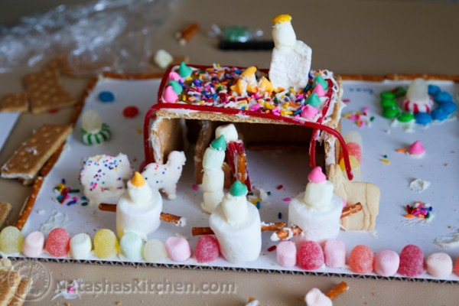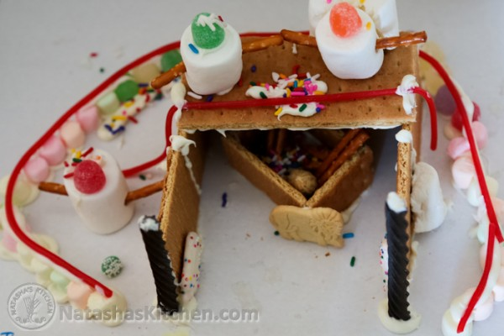

*“And they went with haste and found Mary and Joseph and the baby lying in a manger.” Luke 2:16*

The nativity scene fills our hearts with joy, wonder and hope as we see the gift of our Savior lying in the manger!

Instead of the usual gingerbread house, make a family nativity. It can be very simple, using a cardboard sheet as a base and graham crackers and purchased frosting to make the stable. Then let your and your child’s imaginations run wild! Animal crackers, colored chips, sprinkles and candies, pretzel stick, raisins, licorice strings and marshmallows can be used to create those who were with Jesus in the stable.

**The Joy of Giving**

<http://wellnessmama.com/7090/christmas-joy/?utm_campaign=christmas-joy&utm_medium=rss&utm_source=rss>

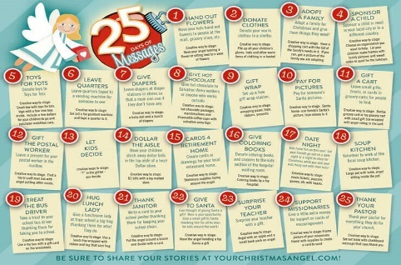

*“For the wages of sin is death, but the free gift of God is eternal life in Christ Jesus our Lord.” Romans 6:23*

Christmas is the time to celebrate the greatest gift the world has ever received-our Lord and Savior Jesus Christ! To help your family focus on being a great gift giver like our great God, encourage them to give unique gifts to those they encounter this Christmas season. Work as a family to give a gift to someone who needs to know of the gift of Christ. Some ideas include:

* Leave a small gift (cookies, candy, etc.) and a card for the postman, newspaper deliverer or garbage collector
* Make cards and take them to a local nursing home
* Write a note of thanks that also celebrates joy of Christ at Christmas to your bus driver, librarian, grocery store clerk, hair dresser, etc.
* Write/make Christmas cards for some neighbors and deliver them

**Christmas in Other Countries**

<https://www.wycliffe.org/Curriculum/Kate%20and%20Mack/dc_des_3785_12%20Days%20of%20Christmas_FINAL.pdf>

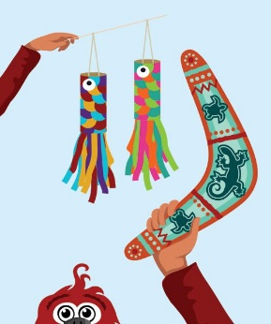

*“And He said to them, ‘Go into all the world and proclaim the gospel to the whole creation.’”*

*Mark 16:15*

God’s gift of grace and salvation from sins that was given to the WHOLE world. Remember this together as a family by reading about another country and doing an activity, craft or making a recipe from another nation. Wycliffe Kids has great ideas! While you are working, celebrating, and creating pray for the people of this nation to know Jesus Christ as Savior and Lord.

**Remember God’s Christmas Blessings**

[**http://thecraftyclassroom.com/2015/12/17/nativity-finger-puppets/**](http://thecraftyclassroom.com/2015/12/17/nativity-finger-puppets/)

[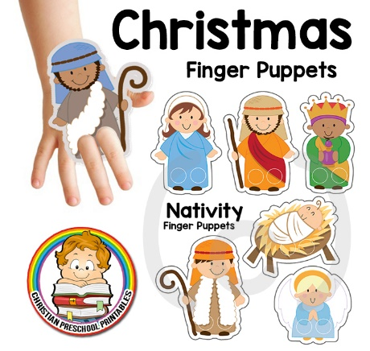](http://www.valeriejayne.com/wp-content/uploads/CPP/Christmas/NativityFingerPuppets.pdf)

*“For to us a child* ***is*** *born, to us a* ***son******is******given****; and the government shall be upon his shoulder, and his name shall be called Wonderful Counselor, Mighty God, Everlasting Father, Prince of Peace.” Isaiah 9:6*

Remembering all God has given to us during this Christmas season helps us to think about all that is true, noble, right, pure, lovely and admirable! As a family, use finger puppets, a nativity set or dress up yourselves to show and share about God’s goodness to us as described in the gospels. Grown-ups or older children can read the scriptures while other family members use the above mentioned methods to act out the Christmas story.